**Process Flow Diagram: CIBA**

**Pre-Reactor**

**Reactor**

**Evaporator**

**Washing Tank**

**ECH Stripper**

**Sludge**

**Salt Packaging**

**Solid Disposal**

**BPA, ECH, NaOH**

**Unreacted ECH**

**NaOH 48%**

**Dehydrated H2O**

**Toluene**

**Water**

**Resin**

**& salt**

**Gravity Separation (with Stirring & settling) stirrer at 60 RPM**

**Recovered ECH**

**Steam 100°C**

**Toluene**

**Steam Stripping**

**(7Bar & 120o C)**

**Filtration Unit**

**Filter Cake**

**Packer**

*FY Note*: Process for Solid & Formulated Resin is the same for Technology 2 (with major difference in process parameter)*

*2015 –FY2030*

**Process Flow Diagram: Tohto kesai**

**Process Details:**

**Pre-reaction Section**

Reaction starts with adding Excessive quantity of Epichlorohydrin (Fresh & recovered) with prescribed quantity of Bisphenol-A by using NaOH as Catalyst. As result of this reaction, Bisphenol-A chlorohydrin intermediate is formed.

**Reaction Section**

Bisphenol-A chlorohydrin intermediate formed from the pre-reaction section is further changed to liquid epoxy resin by reaction with NaOH. Optimum process conditions are maintained in the reactor which minimize hydrolysis of ECH and formation of by-product waste polymer and enables the production of high-quality epoxy resin of the required viscosity at high yields.

**ECH Recovery:** ECH Evaporated during reaction contains ECH and water. Water is stripped off in the distilled unit and pure ECH is recycled for the next batch.

**ECH Distillation:** ECH , Resin & Salt is distilled to recover the pure ECH.

**Refining:** In this sectionwashing & Separation takes place. Toluene and water is added to dissolve resin in it and the salt solution is separated from the resin manually by adding water. Three layers are formed; the resin and toluene stay in the upper layer (called organic layer) & NaCl-water in the lower layer & centre one is the unreacted BPA, it is called emulsion layer. Again, DM water is added to wash the resin and remove the traces of salt from it.

**Dissolvent:** Here solvent recovery is done, Resin along with solvent and suspended salt is steam stripped to recover Solvent.

**Product Finishing Section:** Epoxy resin is finally filtered to remove the traces of impurities.

**Process Flow Diagram: Tohto Kesai**

BPA: 0.690

Pre-Reactor

NAOH:0.0065 ECH: 1.79

Pre-Reactor

ECH: 0.56

Dehydration Water

ECH Stripper

Reactor

NAOH- 0.46

Falling film Evaporator (Under Vacuum)

Fa

Steam Recovered ECH

NAOH: 0.0073 Waste Polymer

Waste Polymer

Process Water (2 Times) Solid Waste

Gravity Separator (Refining)

Toulene(S1): (1.15+1.73)

Wastewater Treatment

De-Hydration

Filtration

Solid Waste

Solid Waste

Steam

Reboiler

Recovered S1

Evaporator

Product=1

**Process Details:**

**Pre-reaction Section**

Reaction starts with adding Excessive quantity of Epichlorohydrin (Fresh & recovered) with prescribed quantity of Bisphenol-A by using NaOH as Catalyst. As result of this reaction, Bisphenol-A chlorohydrin intermediate is formed.

**Reaction Section**

Bisphenol-A chlorohydrin intermediate formed from the pre-reaction section is further changed to liquid epoxy resin by reaction with NaOH. Optimum process conditions are maintained in the reactor which minimize hydrolysis of ECH and formation of by-product waste polymer and enables the production of high-quality epoxy resin of the required viscosity at high yields.

**ECH Stripping:** ECH evaporated during reaction contains ECH along with water. The water is stripped off in the distillation unit while recovered pure ECH is recycled for the next batch.

**ECH Detachment Section**

After the reaction process is done, excessive quantities of unreacted ECH are separated from the product by increasing the temperature and recovered through a vaporizer (Evaporator), the same is returned to the ECH day tank for reuse. The crude epoxy is then sent to the next refining section. In order to protect the epoxy resin from thermal effect, vaporization of ECH is done under vacuum conditions, at the lowest possible temperature and in the shortest possible time.

**Refining**

In this section washing is done, toluene is added to dissolve resin in it. After continuous stirring, the allowed salt solution is allowed to settle in the gravity settler. The salt solution is then separated from the resin manually by adding water. Again, demineralised water is added to wash the resin and remove the traces of salt from it.

**Product Finishing Section:** Finally, Epoxy resin is filtered to remove suspended particle via sparkler filter and is sent to the product tank through mixing tank.

**Dissolvent:** Dissolvent is done to remove the solvent toluene from the resin by passing through falling film thin evaporator & rotary film thin evaporator under vacuum.

1. Major difference btw two technology is process parameter (Pressure, Temperature, Retention time etc.), Solvent, Catalyst, Additives, Hardeners, fillers used etc.
2. In Technology 1 (Tohto Kesai), Filtration is done first, then after distillation is done to recover Solvent used. While in Technology 2 (CIBA), First Distillation (under Vacuum) is done to recover solvent and then filtration is done.

According to the key opinion leaders, the technology employed by Ciba-Geigy AG has low solvent requirement (i.e. Solvent Recovery) than the Tohto Kasei Co. Ltd. technology. Other than this, few variations in process parameters are the only observable differences.

Page No : 114

Liquid Epoxy Resin

Solid Epoxy Resin

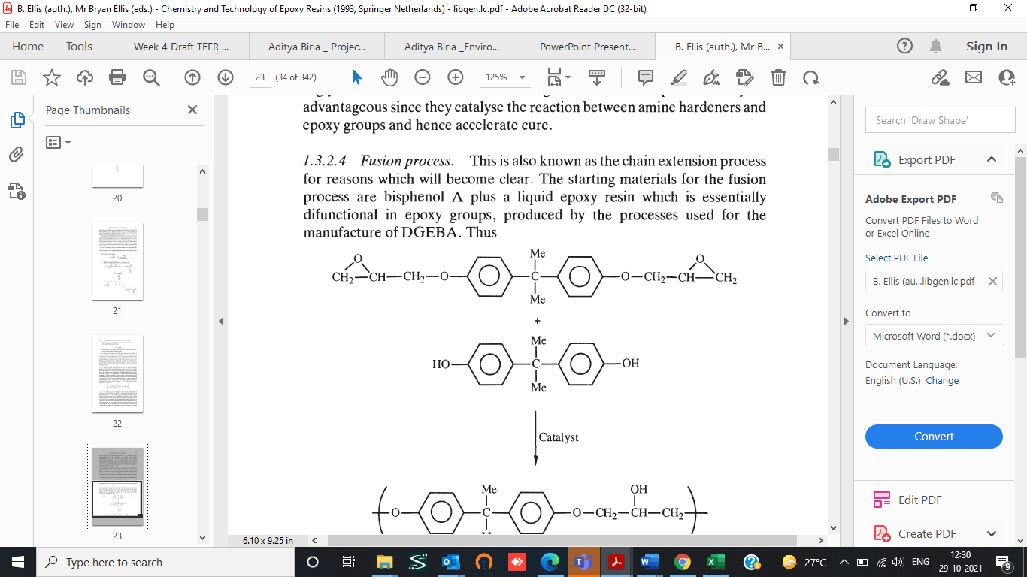

Project Schedule :

|  |  |  |  |
| --- | --- | --- | --- |
| S No | Activity | Start | Finish |
| 1 | Kick off meeting | January, 2022 | January, 2022 |
| 2 | Basic Engineering Document | January, 2022 | February, 2022 |
| 3 | Detail Engineering | February, 2022 | December, 2022 |
| 4 | Procurement & Delivery | September, 2022 | April, 2023 |
| 5 | Construction at site (Building, Mechanical, piping, Electrical, Instrument etc ) | January, 2023 | February,  2024 |
| 6 | Pre Commissioning | March, 2024 | May, 2024 |
| 7 | Process Start up & Stabalization | June,2024 | August, 2024 |